Quality RTC [Network testing](https://togetherseniorhealth.testrtc.com/)

*QualityRTC: Smart VoIP network tests for WebRTC applications by testRTC*

Run this url (at least 3 times per session)

<https://togetherseniorhealth.testrtc.com/>, and also your standard internet speed test, and take screen shots for comparison?

## Chrisanne - Ethernet - MacBookPro - Speedtest application

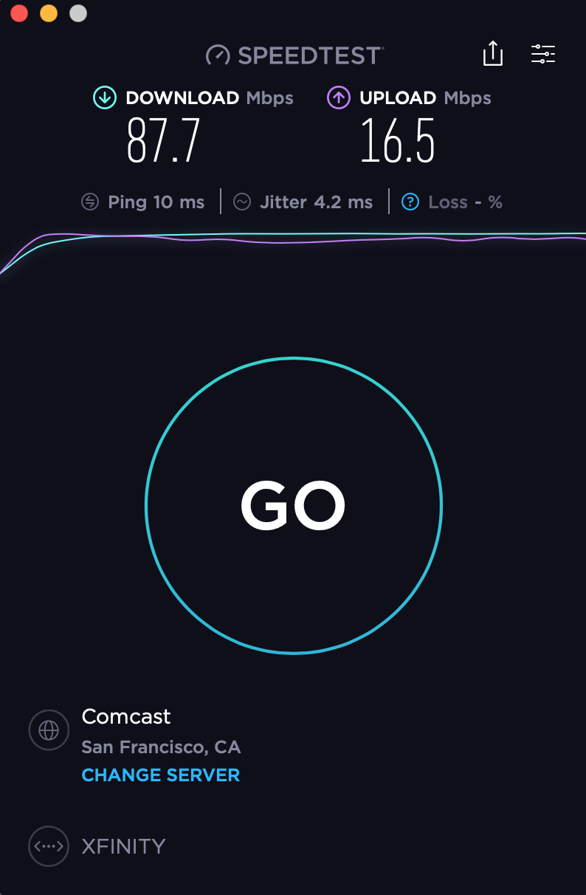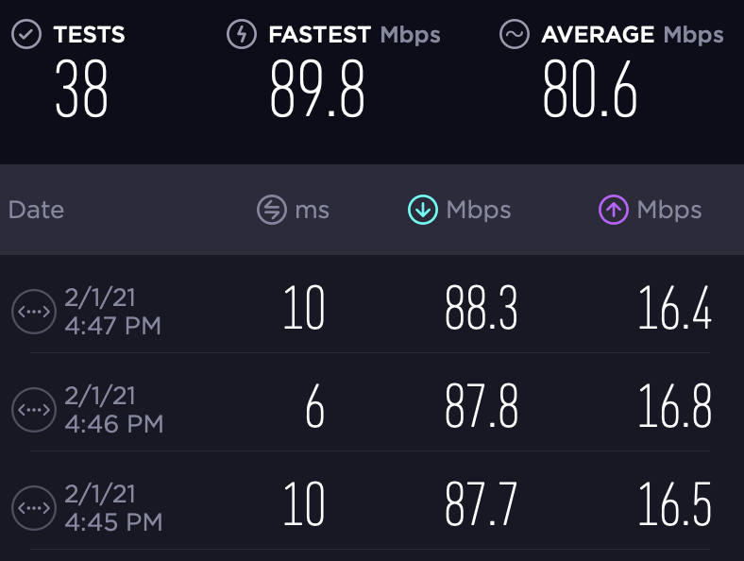

History

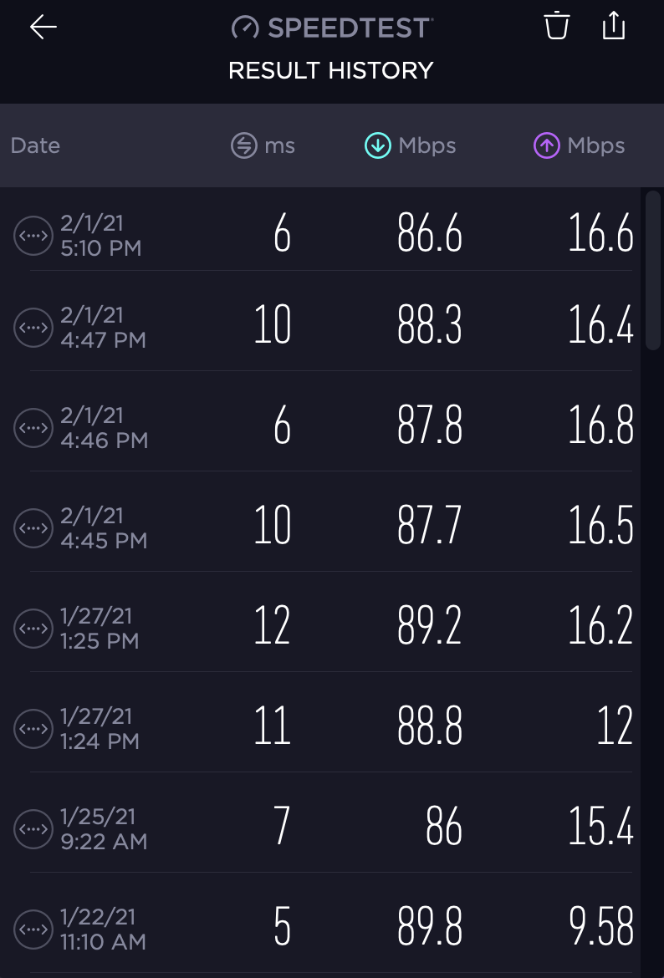

## Chrisanne - Ethernet - MacBookPro - Quality RTC

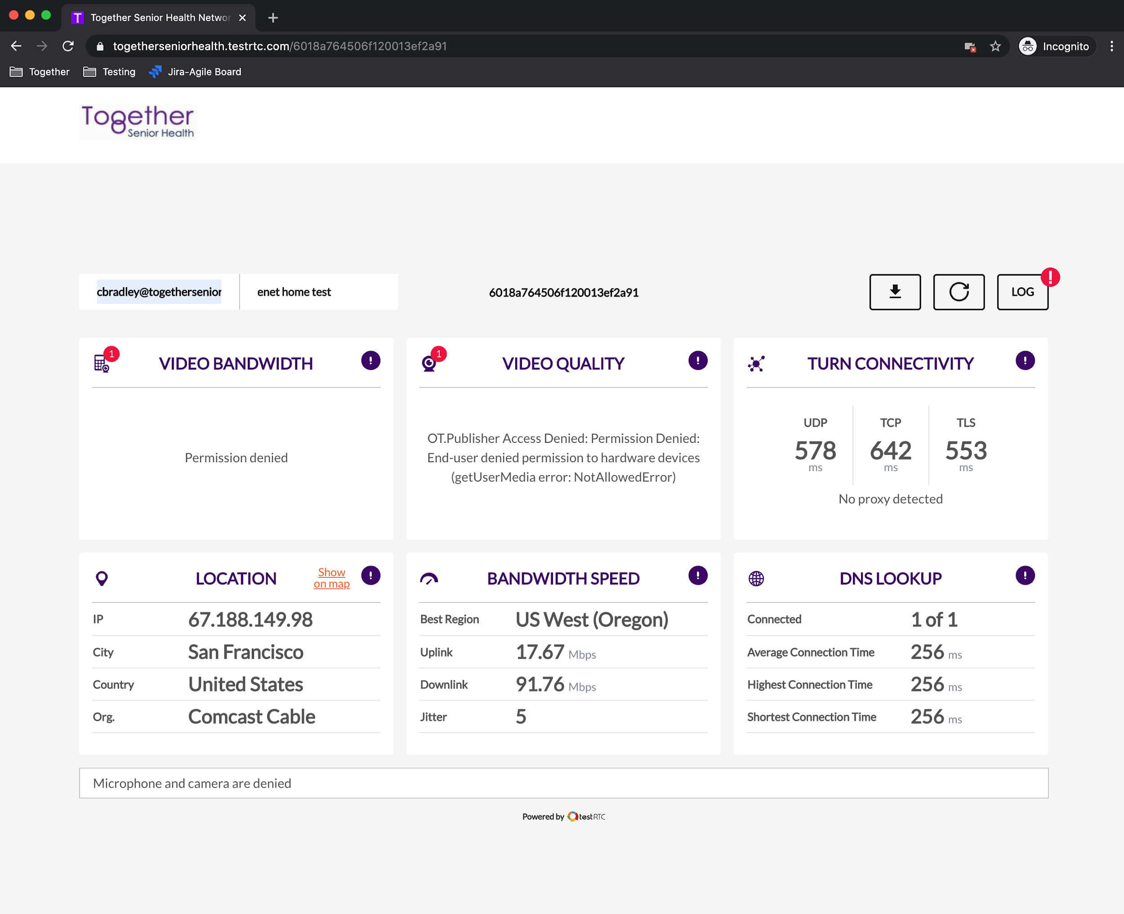

Errors > probably b/c it is not configured for Agora to detect user

[5:13:26 PM] - getUserMedia({"video":true,"audio":true}) failed with Error: NotAllowedError [Microphone and camera are denied]

[5:13:29 PM] - TEST [VideoBandwidth] Permission denied

[5:13:32 PM] === Video Quality Test [VideoQuality:tokbox] ===

[5:13:34 PM] - TEST [VideoQuality] OT.Publisher Access Denied: Permission Denied: End-user denied permission to hardware devices (getUserMedia error: NotAllowedError)

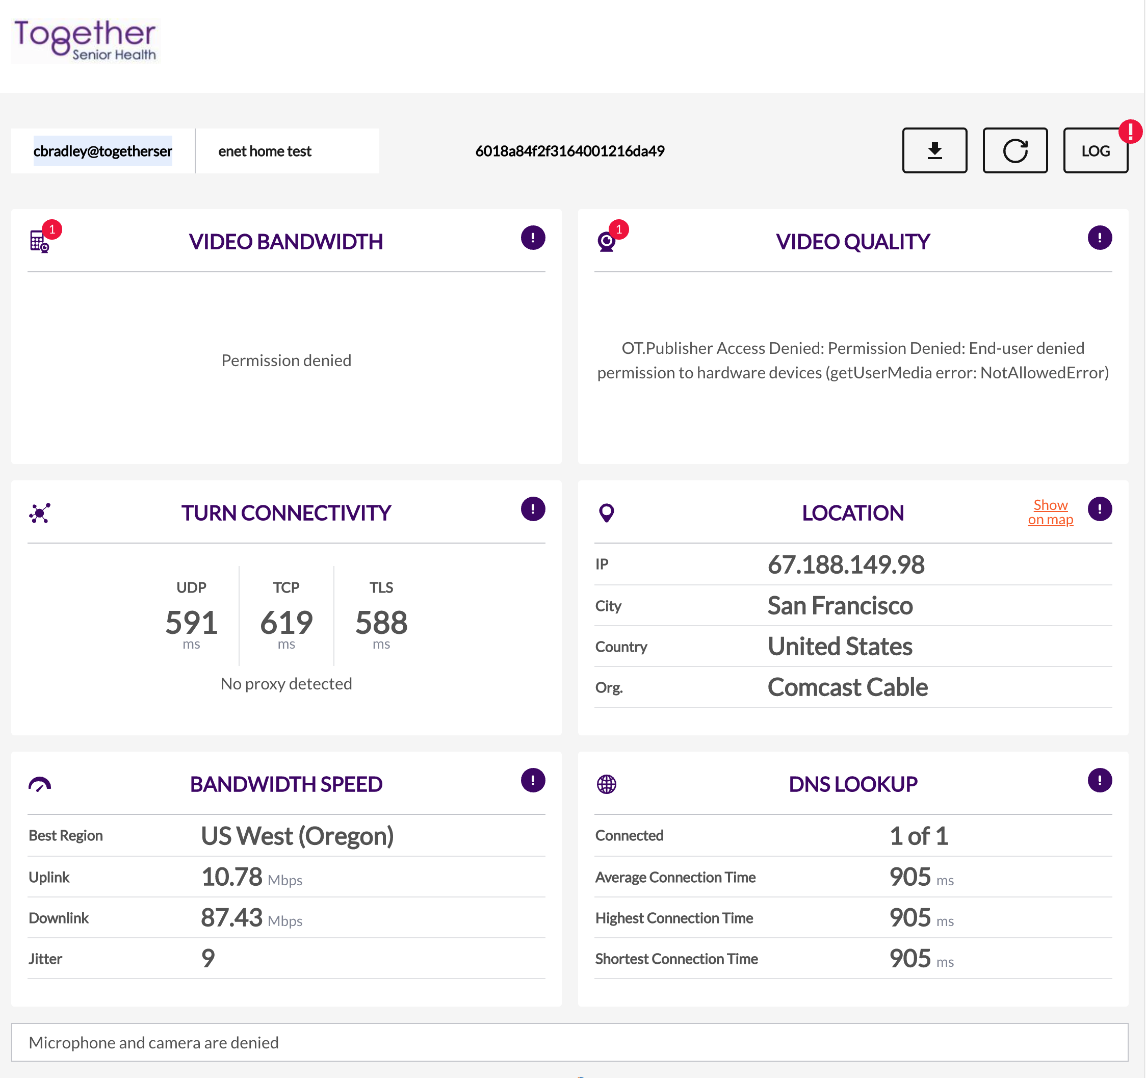

## 

## Chrisanne - WiFi - MacBookPro - Speed test application

## 

## Chrisanne - WiFi - MacBookPro - Quality RTC

2.4 network

